**The Entrepreneurial Process**

**Assignment 3**

*Please answer all text questions in size 11 Arial font unbolded*

*Short answer to single paragraph length answers required*

*Places to write your answer indicated by “Answer:” *

Questionnaire Contents:

* 7 Sections
  + Section 1: 4 Questions
  + Section 2: 8 Questions
  + Section 3: 6 Questions
  + Section 4: 4 Questions
  + Section 5: 2 Questions
  + Section 6: 2 Questions
  + Section 7: 1 Question

**Section 1: Details**

1. **What is your full name?**

Answer: Shahryar Faraji

1. **What is your birthdate?**

Answer: 01/8/1998

1. **What is the name of your business?**

Answer: 1receipt

1. **Please provide some images for an infographic**
   1. **Picture of you:**

Answer: 

* 1. **Picture of your business logo:**

Answer: 

* 1. **Pictures of any promotional material you have for your business:**

Answer: 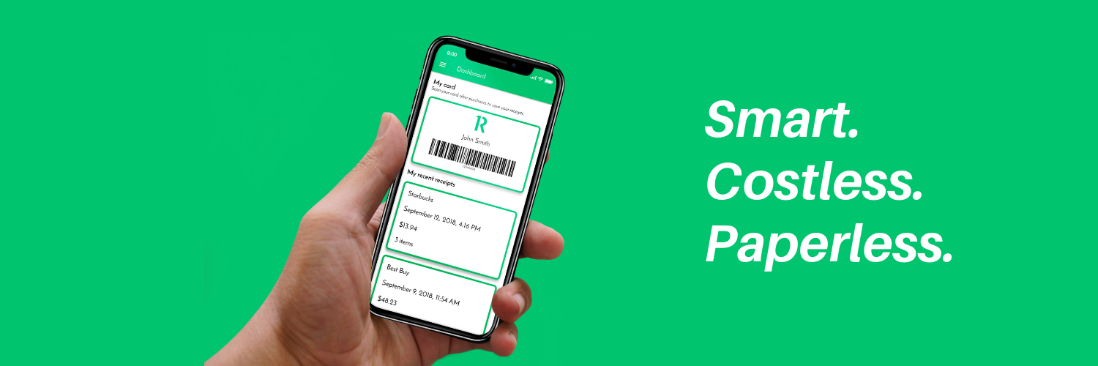

Let me know if you need anymore. You can check our site also -> [www.1receipt.io](http://www.1receipt.io)

* 1. **Picture of your business location/place where you work (If able):**

Answer: LOL (it is RMIT Activator).

* 1. **Picture of your business card**

Answer: 

**Section 2: How the entrepreneur demonstrates the entrepreneurial mindset and the ethical dilemmas the entrepreneur faced**

1. **Which of the three statements do you and your business identify with most?**

|  |  |
| --- | --- |
| **1. A new innovation on the current status quo** | **(I.E. Creating something brand new to the market)**  **(E.G. The invention of the car/internet)** |
| **2. Disrupting the current status quo of your industry** | **(E.G. Uber disrupting the taxi industry)** |
| **3. Harmonizing supply and demand** | **(E.G. Opening a coffee shop in an area where none exist and there is a demand for coffee)** |

Answer: **2**

1. **Describe why you became an entrepreneur? (Specifically mention if it was for “Personal advancement”, “No alternative”, or “Independence”)**

Answer: Independence and unleashing creating to solve real world problem

1. **Subsequently, do you identify as an opportunity-driven entrepreneur or necessity driven entrepreneur?**

Answer: As an opportunity-driven entrepreneur

1. **Please select at least 3 of the following skills and give a quick example on how you demonstrated said skill**

|  |  |
| --- | --- |
| **Inner control** | **Decision making** |
| **Planning and goal setting** | **Human relations** |
| **Risk taking** | **Independence** |
| **Innovation** | **Reality perception** |
| **Use of feedback** |  |

Answer: Decision making - Making decision between what customers needed and what is the core feature of the product

Innovation - 1receipt project!

Risk taking - Try different methods for go to market strategies

1. **Which of these statements describes you with your business? (Provide a 1-2 sentence reason for each you select)**

|  |
| --- |
| **You identify other people’s needs.** |
| **You build a product that meets those needs.** |
| **You repeat until you get it right.** |
| **You are intensely committed.** |
| **You have a determined perseverance.** |
| **You are optimistic.** |
| **You are burning with competitive desire.** |

Answer: All

1. **Do you have a failure in your entrepreneurial journey that you learnt from? If so, what was it and what did you learn?**

Answer: Not yet :)

1. **Have you come across an ethical dilemma regarding your business? If so, what was it and how did you overcome it (If you did)?**

Answer: Nah

1. **Do you identify as a social entrepreneur? (Act as an agent of change - identifying a social problem and using their entrepreneurial skills for social and environmental goals)**

Answer:Not fully. I would say myself I am half of a social entrepreneur. Harder to find a solution for social problem.

**Section 3: Pathway/Venture Process he/she took to start the business**

1. **How did you come up with the idea of your business?**

Answer: Seeing people exiting shops or department stores while they are throwing away large pieces of white papers (shopping receipts) into the nearest bin inspired me to do a half- year-long research to find a solution to prevent wasting such a valuable resource as well as reducing retailers’ cost for issuing paper receipts and making shoppers’ life even easier for storing/retrieving their shopping receipts without revealing their personal information. I then realized that in Australia we must keep our receipts for at least 5 years for GST calculation and other tax purposes – a task which looks practically impractical due to the maximum one-year life span of the thermal paper receipts.

1. **Why did you start this business venture?**

Answer: To solve a big problem which was in the society:

* $350,000,000 paper receipt issuing cost - spent yearly by major retailers ONLY in Australia.
* Personal data sharing risk by Email / SMS receipts.
* 8,500,000 trees cut every year only for paper receipts.
* Serious health issue by touching paper receipts - which can cause cancer in our body [<http://shorturl.at/cjsNW>].
* Hard to convert shoppers into loyal members.

1. **Which entrepreneurial opportunity best describes why you started your business?**

|  |  |
| --- | --- |
| **Want to compete with the existing businesses (Purchase low, sell high)** | **Became aware of a gap in the market** |
| **Want to Innovate (And disrupt existing markets)** | **Social Needs identified (Want to address the social problem)** |

Answer: (((((((Want to Innovate)))))))

1. **Which of these bests describes the pathway of your business?**

|  |  |
| --- | --- |
| **1.Bootstrapping** | **Used other people's resources.**  **Rely on networks and existing resources** |
| **2.Business assistance funding** | **Had access to aid in your venture.**  **E.g. financial funding, business information, training, mentoring** |
| **3.Miniprenurship** | **Started as a niche market and then expanded norm commerce** |
| **4.Classic start-up** | **Began because of one of the following (If so, which)**  **1.Satisfy untapped demand**  **2.Andance the product frontier**  **3.Lower prices**  **4.Broader market penetration**  **5.Drive less innovative products out of the market** |
| **5.Achquiring an existing venture** | **Obtained someone else’s business** |
| **6.Social venturing** | **Driven by the want to find solutions to social injustice or environmental problems** |

Answer: Bootstrapping (Used code fragment bootstraps) Got my first prototype using mostly bootstraps.

Business assistance funding (Activator services and funds)

1. **Please identify some key phases in the process you took to begin your business**

Answer: Concept, ideation, building prototypes (many prototypes), building the MVP and delivering to the first customers for feedback and iterating over it.

1. **Did it follow this flow? (In some capacity)**

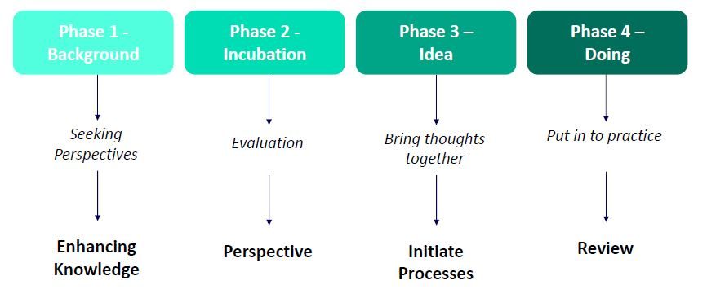

Answer: Yes.

**Section 4: How their business is innovative and helped the entrepreneur to be successful and why**

1. **Which best describes your business and its concept?**

|  |  |
| --- | --- |
| **1. Invention** | **Totally new product, service, or process** |
| **2.Extension** | **New use or different application of existing product, service, or process** |
| **3.Duplication** | **Creative replication of an existing concept** |
| **4. Synthesis** | **Combination of existing concepts and factors into a new formulation or use** |

Answer: Invention

1. **Describe how your business fits the category selected in question 1 of Section 4**

Answer:

* With 1receipt costless service, retailers will not need to waste millions of dollars on issuing paper receipts.
* With 1receipt, shoppers feel Cybersecured. No personal info sharing.
* Preventing cutting millions of trees every year for paper receipts with 1receipt.
* Providing true contactless receipt.
* Creating meaningful customer relationships at the point of sale.

1. **In your own words, how is your business innovative?**

Answer:

1receipt offers a dynamic and completely unique service that comes with countless benefits for both retailers and shoppers. Instead of helping *one* group of people, it benefits *everyone*. Retailers can save money by going digital where shoppers can keep their information safe and ultimately save their time.

The current standard of emailing or text messaging receipts is an ineffective way to eliminate paper receipts. We cut giving personal information out and give people the opportunity to check out faster at shopping centres.

1. **How has your business helped you to become successful?**

**Section 5: What opportunities did the entrepreneur perceive and exploit to develop their business in relation to the forces in the competitive environment**

1. **What hole in the market did you see that your business fills?**

Answer: Mentioned in my problems :)

1. **How is your business different from its competitors? (How does it stand out)**

Answer: 1receipt is give the power to the shoppers to not share any personal information to the retailer and just scan the app at the checkout to get a true contactless receipt. On the other side, we also help the retailers to save costs on issuing paper receipts and create a meaningful customer relationship at a point of sale.

**Section 6: Funding sources they obtained**

1. **What sources of income did your business obtain? (E.g. Self-funded, investors, government loans)**

Answer: Self-funded + funding from accelerator (Activator)

1. **How did you obtain said income sources?**

Answer: Personal contribution

**Section 7: Different approaches**

1. **Is there anything you would have done differently in your business venture? Looking in retrospect. If so, what?**

Answer: Yes, at the early stage get my validation done with actual customers paying for it before building anything.